29.

A teacher uses a straight horizontal piece of wood to make wave pulses at one end of a long tank of water.

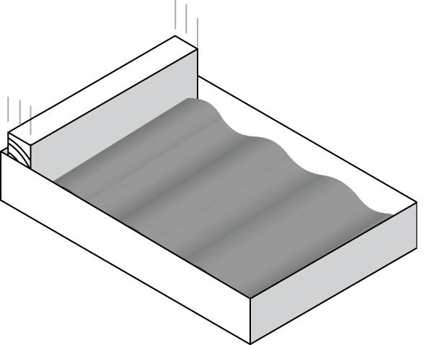
Each pulse of waves gets fainter as it goes, and eventually cannot be seen any more. Which of the following best explains why this is so?

A As the waves move forwards, friction effects make the wave-speed get less.
B As the waves move forwards, friction effects make the amplitude get less.
C As the waves move forwards, friction effects make the frequency get less.
D Water waves are not affected by friction, but just fade out as they lose energy.

